Question 1

Below steps performed on the Linux-based OS (Ubuntu)

**Step 1: Install Apache2**

* Install Apache2:

Update the package list:

* sudo apt update

Install Apache2:

* sudo apt install apache2

Check the Apache2 Service:

* sudo systemctl status apache2

### Step 2: Create a Website

**Create a directory:**

* sudo mkdir -p /var/www/awesomeweb

Create an HTML file inside that directory:

* sudo vi /var/www/awesomeweb/index.html

Example HTML code:

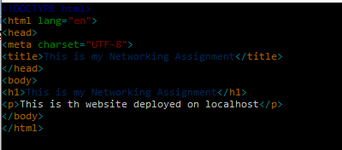

### Step 3: Configure Apache2

Create a virtual host configuration file:

* sudo vi /etc/apache2/sites-available/html.conf



Restart Apache2 to apply the changes:

* sudo systemctl stop apache2
* sudo systemctl start apache2
* sudo systemctl restart apache2

### Step 4: Set up Local DNS (DNS Name: awesomeweb)

To access the website using the custom DNS name awesomeweb, edit the /etc/hosts file.

Open the /etc/hosts file:

* sudo vi /etc/hosts

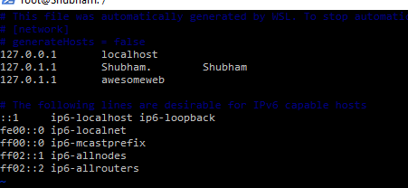

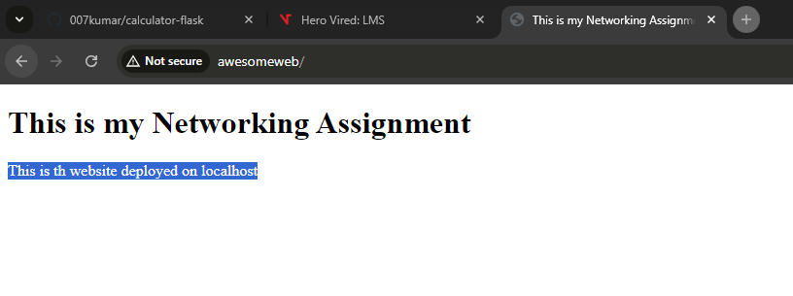

**check the status of the subdomains.**

Create the Directories for Each Subdomain

Sudo mkdir -p /var/www/app.awesomeweb

Sudo mkdir -p /var/www/blog.awesomeweb

Sudo mkdir -p /var/www/shop.awesomeweb

Create HTML Files for Each Subdomain













Create Virtual Hosts for Each Subdomain



sudo a2ensite app.awesomeweb.conf

sudo a2ensite blog.awesomeweb.conf

sudo a2ensite shop.awesomeweb.conf

sudo systemctl stop apache2

sudo systemctl start apache2

sudo systemctl restart apache2

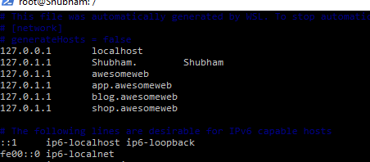

1. 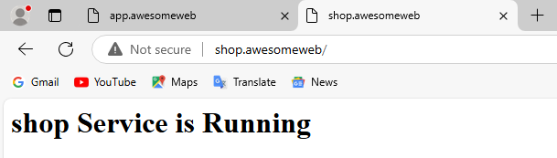
2. 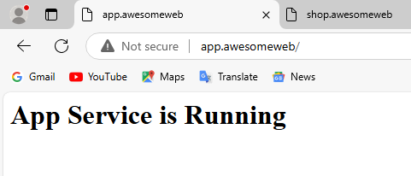
3. 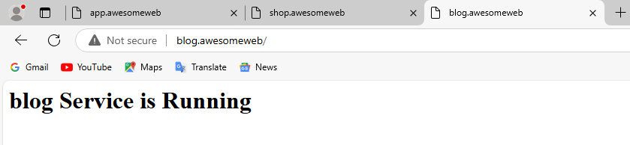

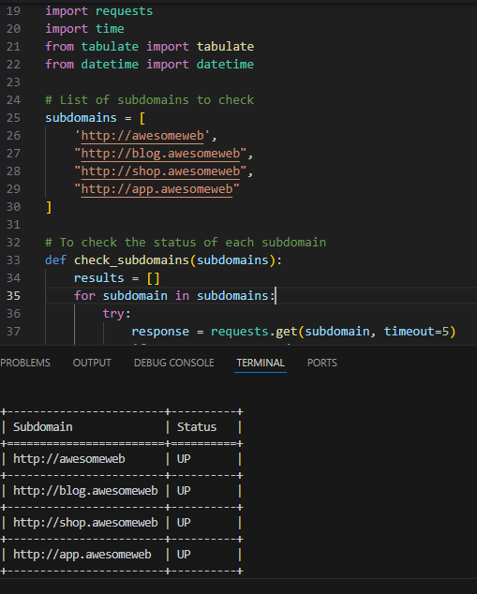

**Install Oracle VirtualBox**

Using Windows OS we fist need to download Virtualbox for windows installer:

- double-click on the downloaded file to start the installation.

- Follow the on-screen instructions and accept the license agreement.

- Choose the components you want to install and the installation path.

- Complete the installation process.

- After installation we will download the Linux required version from the below link

[https://releases.ubuntu.com/22.04/?_gl=1*2pm8cw*_gcl_au*MTI0NjMwNTUxNS4xNzI3OTI0NzIw&_ga=2.5330875.985289324.1727924718-340603492.1727924718](https://releases.ubuntu.com/22.04/?_gl=1*2pm8cw*_gcl_au*MTI0NjMwNTUxNS4xNzI3OTI0NzIw&_ga=2.5330875.985289324.1727924718-340603492.1727924718)

Now we have to install the ubuntu OS on the Oracle Virtualbox.

**Open Oracle Virtualbox** app > **New** > Provide **name** and **OS file** in OS Image.

Now start the default process using OS boot image. During the installation, select the defaults and create a user account.

Now after we get VM ready we need to start the VM > it will show login page with username as **vboxuser (login using password as>** changeme**)**

**After login to the VM it shows error as below:**

***vboxuser is not in the sudoers file .This incident will be reported!***

Now to add vboxuser to sudo group need to follow below steps.

We need to restart the VM and press **Ctrl + Alt and Del**

Run the following command, replacing **vboxuser** with the actual username you want to add to the **sudo group**:

* ***sudo usermod -aG sudo vboxuser***
* ***groups vboxuser*** (To verify that the user has been added to the **sudo** group, run)

**Install Nginx and Host a Website**

* *sudo apt update*
* *sudo apt install nginx -y*

**Start Nginx and Verify the Installation**

* *sudo systemctl start nginx*
* *sudo systemctl status nginx*
* Open a web browser inside the VM and go to http://localhost.
* You should see the default Nginx page that says "**Welcome to nginx**!".
* *sudo nano /var/www/html/index.html*

***Configure html file***

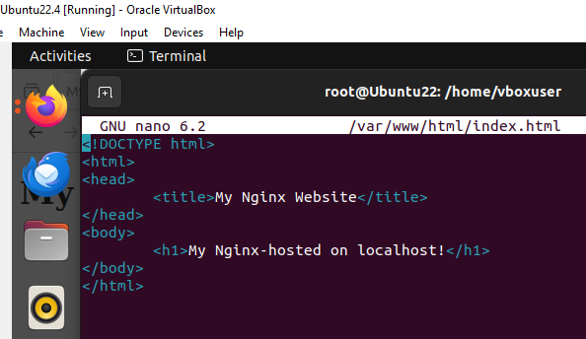

*Host entry need to be modified in* ***/etc/hosts***

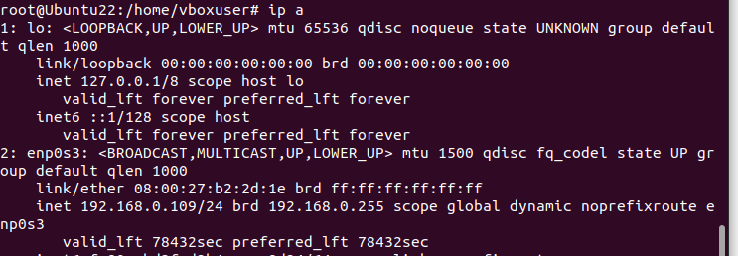

*Host entry done for IP address 127.0.0.1 as below*

* *127.0.0.1 localhost*

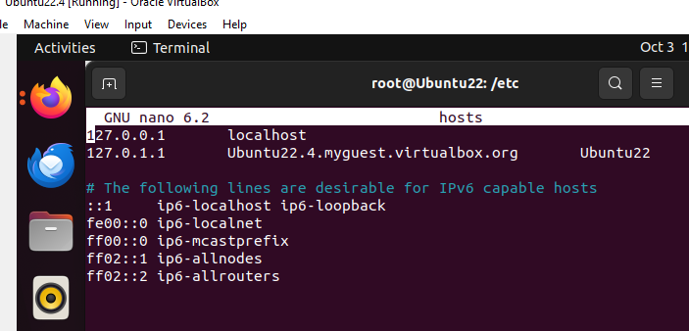

***Restart Nginx service***

* *systemctl stop nginx*
* *systemctl start nginx*
* *systemctl restart nginx*

